02.04
Aircraft & Comp. Counters
Process Design & AMOS Configuration Document
Purpose
This Process Design document is provided to Key-Users to record their key decisions regarding the AMOS Process design and the required AMOS configuration.
It is updated throughout the Project Definition Phase and used as the baseline for the Final Acceptance prior to Go-Live
Revision
Author, Name | Date | Notes
Swiss-AS Consulting | 02.06.2024 | Draft

Table of Contents
1. Process Overview & Objectives 3
2. Regulatory References 3
3. Definitions & Glossary 3
4. Process Tasks 3
5. Process Dependencies 3
6. Process Flow 4
7. Process Design Questions 5
8. Data (Source) Mapping 6
9. Other Software Used 6
10. AMOS Configuration 7
a. Basic Data 7
b. Parameters 7
c. Workflows 7
d. Scheduled Tasks 7
e. API’s & Interfaces 7
11. UAT Guidance 8
12. Annex – Additional Info 8

Process Overview & Objectives

Process General Description:
One of AMOS’s primary components for effectively managing your fleet and equipment is through its Counter Management framework. Counters are necessary to manage your Aircraft, Equipment and components Continued Airworthiness as they are the basis for all scheduled inspections and preventative maintenance. The Aircraft and component counter process deals with the creation, modification, and management of aircraft and component counters this includes the updating of individual counters either through automatic flight log imports, or manual data entry through various AMOS programs. AMOS also incorporates a built-in counter correction program that is used to make corrections to counters that were updated incorrectly, this also includes a calculation and consistency checker to ensure there are no inconsistencies between parent and child counters.
The counter concept in short:
- What a counter counts depends on its counter definition
- How it counts depends on the template setup (Master, Child, Standalone, Readable)
- For what it counts depends on the concrete counter reference (A/C or rotable the counter got installed/added on)

Main Process Objective (Outputs & Outcomes):

Regulatory References

- EASA AMC M.A.306(a) Aircraft technical log system
- EASA Appendix V to AMC M.A.704 — Continuing airworthiness management exposition
- FAA AC 91.70C Oceanic and Remote Continental Airspace Operations
- FAA 14 CFR Part 91.417 Maintenance Records
- FAA 14 CFR Part 121.367 Continuous Airworthiness Maintenance Program (CAMP)
- FAA 14 CFR Part 25 Instructions for Continued Airworthiness
- FAA 14 CFR Part 33.7 Engine ratings and operating limitations
- FAA 14 CFR Part 26 Continued Airworthiness and safety improvements for transport category airplane
- FAA 14 CFR Part 43.12 Maintenance Records
- FAA 14 CFR Part 121380 Maintenance recording requirements

Definitions & Glossary

Key-Words | Explanation
Counter | A single counter counts depends on its counter definition, it counts depends on the according template setup (Master, Child, Standalone, Readable, Hybrid) and it’s counts depends on the concrete counter reference (A/C or rotable the counter got installed/added on)
Readable counters | Readable counters are counters which should/cannot be calculated by AMOS. These counters could be used for example for components which provide its own physical counter, and the display value of that component needs to be feed into AMOS from time to time. Doing a readout on such a counter creates a counter value with a certain delta value and can be in reference to one of the following types:  - Flight Log 2 Leg  - Inspection Details  - Label  - Leg  - Receiving  Workorder
Master & Child counter | Is a concept where child counters inherit its values from the master counter it’s linked to. This brings the advantage that a child counter will only get a single readout for the whole time it was linked to a particular master counter. A child can be linked to one master counter at the time but can be linked to various masters during its lifetime or also be in an unlinked state. Manual readouts cannot be performed.  A typical example would be a master C counter on the A/C and a child C counter on a rotable (and the rotable is installed on the A/C). While the master counter gets a readout for every flown leg of the A/C the child counter would only get a readout at installation and another at removal.
Standalone Counters | Standalone counters can be either, readable or calculated. But they cannot be a master or a child counter, they are standalones.  A typical example where to use a standalone counter is the D (Calendar Days) counter
Hybrid Counters | Hybrid counters can be either Master or Standalone counters. The counting logic can be feed by an interface and manual readout can be added (e.g., Engine cycles are delivered via the aircraft cycles plus the engine run on ground can be added manually).
Calculation Formulas | The delta of formula based counter value gets calculated according to its defined formula.  The calculation formula can be either defined at counter definition level or individualized at counter template level.
Counters | Please see Chapter 7 - 03.06 Counter Setup and
Flight Log | The flight log describes the module where flight utilization entries for each individual tail-sign can be created and amended with additional operational or technical related content (e.g., oil uplift, crew, etc.)

Process Tasks

Business Process Task / Actions / Activities:
- Create Counter Definition
- Create or modify Counter Template
- Create and initialize A/C counters.
- Create and initialize component counters.
- Create Flight log (APN 1573) or Aircraft utilization (APN 206)
- Modify/Correct existing Flight log (APN 1573) or Aircraft Utilization (APN 206)
- Perform Counter Readout (APN 1418 or APN 2644)
- Perform Counter Corrections and Check Consistency (APN 2031, APN 147, APN 308)

Process Dependencies

Input | Concurrent | Output
02.01 Aircraft Phase In | 01.01 Aircraft Definition | 03.02 Planning
08.02 Performing Maintenance | 01.02 Part Definition

Process Flow
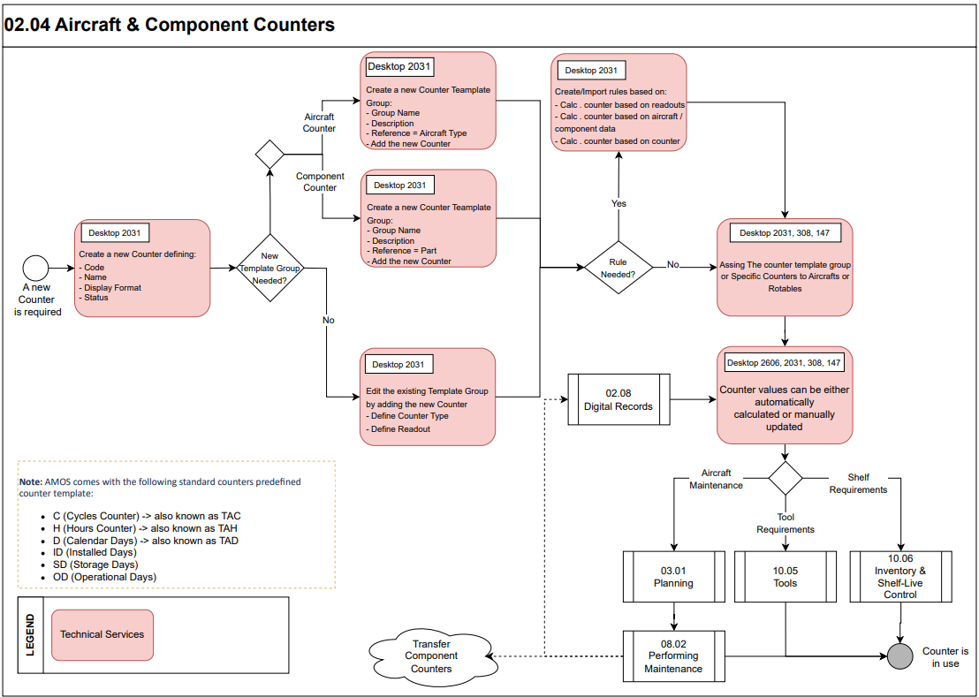

Process Design Questions

# | Question | Answer
1 | Are you using nonstandard counters (H = hours / FH = flight hours, C = cycles / FC = flight cycles, D = calendar days) to perform specific calculation?
2 | How do you currently track your APU hours? Is it a readout with an average defined for planning purposes, or is it calculation based?  Note: some customers use a calculation ratio to measure the APU Hours:  1 FH = 0.x AH
3 | Will the engineering have to use special counters like engine cycles counter which is counting whenever the engine runs (e.g., during regular flights and during ground runs)?
4 | Does your company control Shelf Expiry and in which way?
5 | Do you apply thrust/weight ratings?
6 | How do you Calculate Aircraft/component utilization?
7 | How do you load aircraft utilization records, will you interface to an operations system?  Note: Netline & AIMS have a native interface that requires a specific license. Other programs can be interfaced via the AIM Schema TRANSFER_EXECUTED_FLIGHTS.
8 | If interfacing which interface will be used? Future Flights, Scheduled Flights, Executed Flights?
9 | If future flights how many days in the future?  Note: usually max 2 weeks; schedule can be however transfer for as farthest future as F-OPS uses tail assignment
10 | Does your company use a unique Tech Log and Flight Log, or are they separated?
11 | Who enters the flight log data in your company? Please describe the process.

Data (Source) Mapping

Data Sources | Description | Volume / Manual / Automatic / Static / Dynamic
- | - | -

Other Software Used

Other Softwares | Used by: | Description
Operations System | Flight Ops | Systems such as Netline, AIMS, NavBlue used for flight planning and dispatching

AMOS Configuration

Form Configuration:
- Flight Log Form Config used to modify the fields for APN 1573
- Counter Management Form Config used to modify the fields for APN 2031

Basic Data

Basic Data Table | Notes
Coordinated Places | Currently they are only used for modules Flight Log and eTL. Flight Logbook to be able to enter a departure & destination place other than a station code for a flight.
Autoland Failure Categories | Different failure categories for the Autoland can be specified here.  Please notify, that it is easiest, if you define the default failure category as entry with ID = 1.
Approach Types | Define the approach types and its possibilities here.
De-Icing Mix | The fluid mix for de-icing of an aircraft. This is a customized field and don`t have to be filled.
De-Icing Type | The fluid types for de-icing of an aircraft. Please specify at least one entry with type "N/A"
Fuel Type | Add/edit the fuel types here. Fuel types JP1 to JP 8 are prefilled.
Crew Role | Define the possible roles that your crew can have here.  When adding crew members to a leg in flight...
Limitation Type | The entries define the type of limitation or downgrade.  The lower the order number, the more restrictive the limitation or downgrade.
Rating Category | This table contains the different ratings category i.e., Weight, Thrust Rating ...
Rating | This table contains the different Thrust and/or Weight ratings.
LPF Category | The LPF will be used to calculate under a certain condition (e.g., If A/C flies through Volcanic ash). The entry will be done via Flight Log (APN: 1573) but the formula calculation must be setup in Counter Management (APN: 2031).
Service Type Codes | Here, one can define so-called "Service Type" codes of a flight. They are used to identify the type of flight

Parameters

Parameter Code | Parameter Name | Notes
974 | ALLOWED TAH/TAC DIFFERENCE | When the actual aircraft hours/cycles are not always up to date, the default range of +/- 0 hours/cycles does not give the possibility to enter the correct data in the different programs dealing with TAH/TAC fields.  Therefore, this parameter gives each customer the possibility to adjust this range according to his own needs.
1403 | NOTIFY TAH-/TAC-CHANGES THRESHOLD | With this parameter here, one can trigger the sensitivity at which potential users are being informed about TAH/TAC changes. With the "Publish_TAH_TAC_ChangesIn_ac_utilization" task

Workflows

Workflow Number | Workflow Name | Notes
22 | Enter A/C Utilization Data | This workflow is triggered right before a modified / newly entered aircraft utilization entry is made permanent in the database. It is only effective for AMOS client users (i.e. not effective on the server side, e.g. when importing flight log data from another system). One could use the wildcards of this workflow e.g. to disable new entries, where the hours or cycles value of the leg exceeds a definable value.
63 | Retroactive changes of TAH/TAC for legs detected | This workflow is triggered, when the dedicated scheduled task job "Publish_TAH_TAC_ChangesIn_ac_utilization" (in the AMOS module "Scheduler Task Editor") is active and has detected retroactive changes in the TAH- or TAC-values of arrived legs.
227 | Flight Log 2 Leg Modification | This Workflow gets triggered before you can move on in the Flight log 2 wizard or press the save button when entering the leg data.
314 | Counter Calculation | This workflow gets triggered when any error occurred during counter recalculation or on any changes on automatically created counter correction values
389 | Counter Readout (pre-save) | This workflow is triggered before saving counter values within the counter management module.

Scheduled Tasks

Scheduled Task Reference | Frequency | Notes
FlightOpsImportTask | 1 min to 24 hr.  Depends on op and external sys | used to regularly import Flight OPS information (executed flights, future flights, delays or cancellations) from external systems using either files in predefined XML or TXT format either a direct connection to a Netline System.
CounterCheckService | After Migration  Monthly | Used to check and report counter inconsistencies
Publish_TAH_TAC_ChangesIn_ac_utilization | daily | This task regularly checks for changes in the TAH or TAC values of legs in the table 'ac_utilization'. If the task finds some changes, then a workflow is triggered to e.g., inform some users of the changes.

API’s & Interfaces

Reference | Direction | Trigger | Frequency
TRANSFER FUTURE FLIGHTS | Import/Export
TRANSFER FLIGHT SCHEDULE | Export
TRANSFER EXECUTED FLIGHTS | Import/Export
IMPORT AIMS FUTURE FLIGHTS | Import
IMPORT AIMS EXECUTED FLIGHTS | Import
EXPORT COUNTERS | Export
IMPORT FLIGHT LOG | Import
IMPORT FLIGHTS | import
IMPORT NETLINE LEG DETAIL | Import
EXPORT SRT COUNTERS | Export
TRANSFER COMPONENT COUNTERS | Import/Export

UAT Guidance

# | Sample Test-Cases to be considered
1 | Create Counter Definition
2 | Create or modify Counter Template
3 | Create and initialize A/C counters.
4 | Create and initialize component counters.
5 | Create Flight log (APN 1573) or Aircraft utilization (APN 206)
6 | Modify/Correct existing Flight log (APN 1573) or Aircraft Utilization (APN 206)
7 | Perform Counter Readout (APN 1418 or APN 2644)
8 | Perform Counter Corrections and Check Consistency (APN 2031, APN 147, APN 308)

Annex – Additional Info

Standard Counter Definitions
AMOS comes with the following standard counters predefined counter template:
- C (Cycles Counter) -> also known as TAC
- H (Hours Counter) -> also known as TAH
- D (Calendar Days) -> also known as TAD
- ID (Installed Days)
- SD (Storage Days)
- OD (Operational Days)
These are reserved counter codes, and its definition cannot be modified. C, H and D counters will always be added when creating an A/C or rotable (Def.A/C_TYPE & Def.Parts). ID or SD will be added during receiving on components which require these counters if a requirement with these dimensions exists.

Counter Setup Decision Matrix
Type | Readable | When to use
Master | Y | If the readouts cannot be calculated within AMOS and the counter should be able to inherit its values to children.  Typical examples:  Component counter such as APU hours
Master | N | If the readouts can be generated automatically with available data in AMOS and the counter should be able to inherit its values to children.  Typical examples:  Aircraft counters such as H (TAH) or C (TAC)
Child | Y | No use case now
Child | N | If the readouts can be generated automatically with available data in AMOS and it is sufficient to have only intermediate readouts when linking/unlinking from its master. If the formula needs other data than the reference of its master counter can provide, a standalone counter must be used (for example the child needs „Rotable Data‟ wildcards, calculation cannot be done on a master counter on the A/C).  Typical examples:  Component Flight Hours or Cycles
Standalone | Y | If the readouts cannot be calculated within AMOS and there is no need to have child counters that inherit its values.  Typical examples:  Component counter such as APU hours
Standalone | N | If the readouts can be generated automatically with available data in AMOS and there is no need to have child counters that inherit its values.  Typical examples:  Calendar Days, Installed Days, Storage Days
Hybrid | Y | Hybrid counters can be either Master or Standalone counters. The counting logic can be feed by an interface and manual readout can be added.  Typical examples:  Engine cycles are counted via flight cycles (e.g., EC = FC) plus the engine run on ground can be added manually.

Integration in AMOS
The counter framework is currently integrated into the following programs:
- Aircraft Administration (APN 308)
- Aircraft Utilization (APN 206)
- Component Inspection & Records (APN 2293)
- Flight Log (APN 1573)
- Goods Receiving (APN 2121)
- Rotables Label Booking (APN 150)
- Rotables Administration (APN 147)
- Workorder (APN 1418)

Use Case (Engine ATR 72-600)
Operator of ATR aircraft which are equipped with PW127M engines are obliged to track the so-called Low Cycle Factor (LCF) per life-limited component (LLP). Depend on the component, this factor can increase or decrease the LLP limitation for the subcomponent of the engine. This special counting logic is mainly related to the RH engines where on specific airports the engine can be used as Ground Power Unit (GPU) and therefore doesn’t need to be switched off between the arrival and the departure (refer to picture below). Therefore, the LLP calculation for this engine is different from the calculation of the cycles of the airframe. In addition, a Reserve Take-off Mode (RTO) can be used by the pilots which increases the engine cycles counter per component with a certain Flight Cycle Factor (FCF). The FCF is dependent on the component and is individual counted per engine component based on the documentation of the engine OEM.
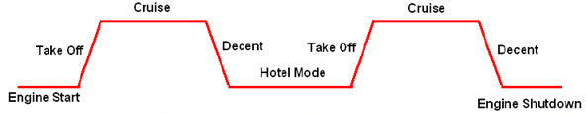

Figure 1: Leg Pattern including Hotel Mode Condition

As mentioned before the right-hand engine is affected by the special calculation of the hotel mode and need therefore individually calculation by the following formula:

Example:
Abbreviated Cycle Factor | 1.0
No. of Starts | 2 (Hotel Mode in Use on between two legs)
No. of Flights | 3
Flight Count Factor | 1.5

Even if the airframe just performed 3 cycles the component must be calculated with 4.5 cycles according to the equation.
This equation is applicable for both engines, but the LH side doesn’t use the hotel mode setting. Therefore the “No. of Start” is equal with the “No. of Flight”. This is leading to the following simplified equation:
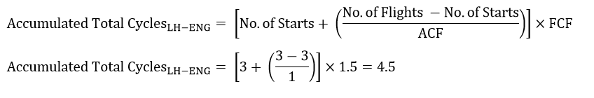
The following condition can be setup in AMOS Counter Management APN 2031 with the following counter rule:

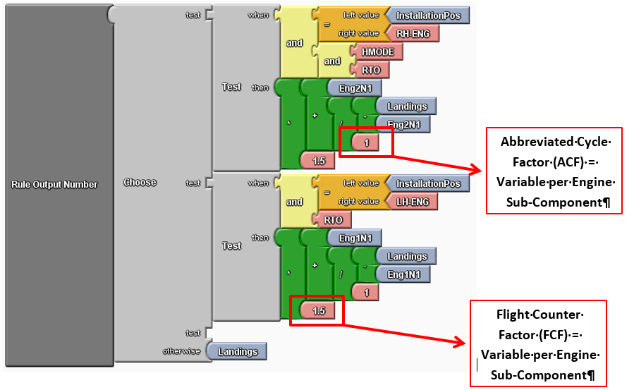

Conditions:
Installation Position | This information is obtained from the data in Rotable Administration APN 147
HMODE (Hotel Mode) | This Life Penalty Factor (LPF) will be entered for each flight log in APN 1573 (if true the HMODE must be ticked on each flight leg)
RTO (Reserve Takeoff) | This Life Penalty Factor (LPF) will be entered for each flight log in APN 1573
ENGxN1 (Engine Cycles for ENG1 OR ENG2) | This data must be entered in flight log APN 1573 per leg
Landings | This data can be obtained from the automatic transfer of the executed flights or needs to be entered in aircraft utilization APN 206 manually.

The above illustrated rule for the engine’s cycles count is counting in the following sequence:
- If the first TEST” condition is matched by all conditions as defined per AND (logical operator) then the calculation equation (green part) will be triggered for the given conditions.
- If the first “TEST” condition didn’t match BUT the second “TEST” condition is matched, then the calculation equation of the second rule will be applied.
- If none of the “TEST” condition is matched, then the logic will calculate with the landing input from the flight log. This is the standard condition if none of the “test” conditions is applicable.

Nevertheless, in all three cases the delta-Value will be added to the last known counter value and is increasing the value by the delta:
New Counter Value = Last Counter Value + Delta of Counter Calculation

Recommendation for Default Template Groups
AMOS is delivered with 2 different Default Template Groups:
- DEF. A/C TYPE
The counter template group consist of the D (standalone) FH/FC counter (master counter).
- DEF. Parts
The counter template group consist of the D (standalone) FH/FC counter (child counter).
Because specific requirements are applicable based on the Maintenance Program (e.g., to track the Life Limited Component for APUs) it is necessary to add these specific counters to the default template groups.
Therefor SWISS AS highly recommends to add the specific counters either to the DEF. Group or generate new default groups as follows:
- DEF. A/C TYPE_ALL
The counter template group consist of the D (standalone) FH and FC counter (master counter) and the AH and AC (child counter).
- 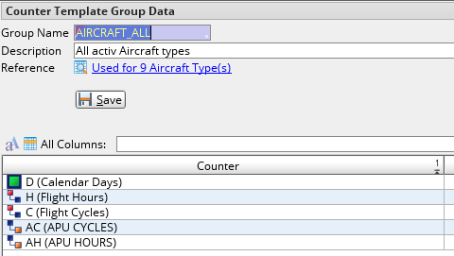
- DEF. Parts
The counter template group consist of the D (standalone), FH and FC counter (child counter).
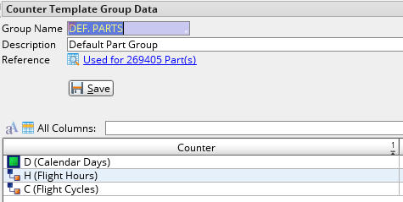
- DEF. Parts_SD
The counter template group consist of the D/SD (standalone counter) and FC/FH (as child counter).
- 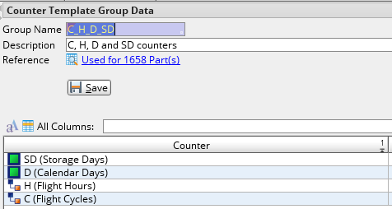
- DEF. APU
The counter template group consist of the D/SD (standalone), AH/AC (master counter) and the FH/FC (child counters).
- 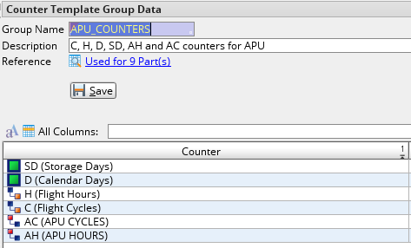

Ratings
As of AMOS 12.20 it is possible to assign Ratings to individual Rotables. Ratings are used in conjunction with the Pro-rated Life Limited Requirements to calculate the Life Limit Utilization, ToGo and Next Due values.
Ratings can be assigned to A/C in Aircraft Administration (APN:308), Rating tab.
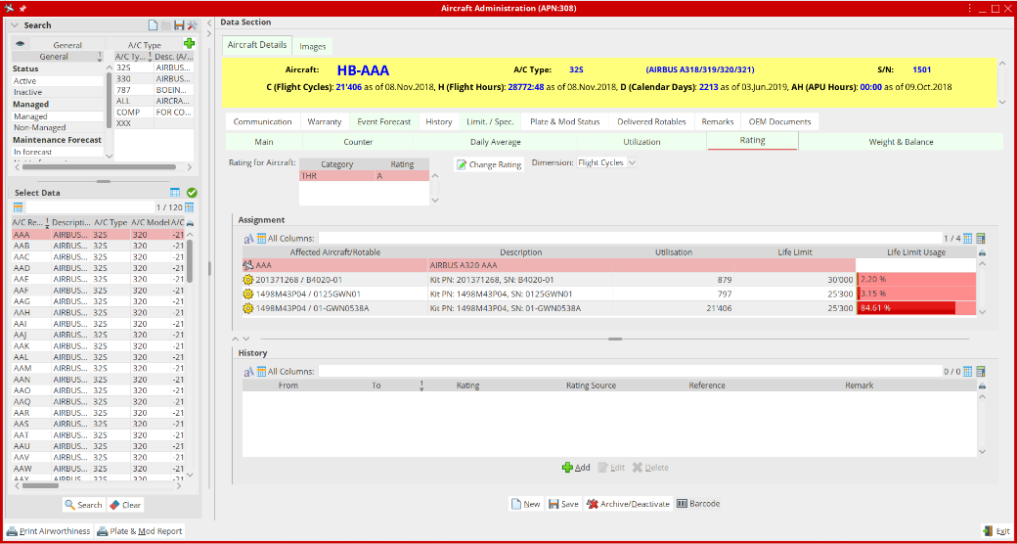
Ratings can be assigned to Rotables in Rotable Administration (APN:147), Rating tab.
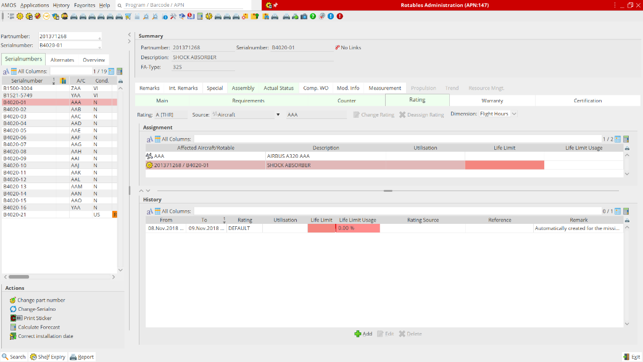
Ratings can be assigned to Rotables in Component Inspection & Records (APN:2293), Requirements tab, Rating section.
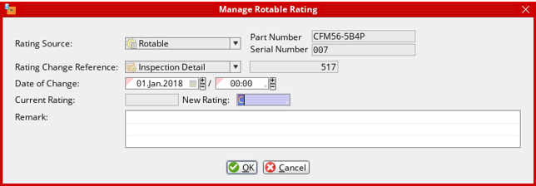
- Ratings can be assigned to A/C and to the highest Assemblies.
- The Assembly Rating has Priority over the A/C Rating.
- If a Rotable is installed in an Assembly, it inherits the Rating of the highest Assembly.
- If the highest Assembly doesn’t have a Rating assigned, all the Rotables within the Assembly inherit the A/C Rating, if assigned.
- If a Rotable is not installed in an Assembly, it is allowed to have its own Rating.
- A Rotable loses its previously assigned Rating when installed in an Assembly.
Pro-rata utilization History can be entered in Aircraft Administration (APN:308), Rating tab, in Rotable Administration (APN:147), Rating tab and in Component Inspection & Records (APN:2293), Requirements tab, Rating section.
Important: During upgrade, in case AMOS determines discrepancies between the total component counter value and the corresponding total pro-rata utilization, additional pro-rata utilization history entries are automatically created for the delta values using the current Rating limits.
Covered Scenarios:
- The A/C Rating in inherited by all the Assemblies and Rotables installed in the A/C.
- The A/C Rating in inherited by Rotables without and assigned Assembly Rating installed in the A/C. The Assembly Ratings are inherited by the Sub-assemblies and Rotables within the Assemblies.
- The Assembly Ratings are inherited by the Sub-assemblies and Rotables within the Assemblies.

